Website
- FAQ section at the bottom, none of the questions have answers, please find the answers below…
A1. Our assistants at JuggleJoy can help you with those fussy everyday tasks that take lots of time out of your daily schedule. Delegate booking medical appointments, party planning, holiday arrangements and home maintenance tasks effortlessly with our easy-to-use platform. This gives you more time to spend with family while your to-do list gets done and dusted!

A2, Delegating a task is simple. Log in to your JuggleJoy account, navigate to the task delegation section, and provide details such as the task description, deadline, and any specific preferences. Our assistants will take it from there, keeping you in the loop with real-time updates on how each task is progressing.

A3, We like to keep things simple, which is why we have a subscription-based model with a single-price plan of £126/mo. No hidden fees or additional charges - guaranteed.

A4, Whether you have just a couple of things on your to-do list or a chore mountain to climb, you can delegate as many tasks as you want with JuggleJoy. We have flexibility with our subscription model to meet your family's unique needs and schedule. We also understand the need for recurring tasks, and you can easily allow our assistants to manage ongoing responsibilities for your family.

A5, You can set deadlines when you delegate a task via your JuggleJoy account, but you will need to give a notice period of 36 hours before you want the task to start.

Registration:
- Remove the word “Optional” from the Mobile No box, this option isn’t optional as the number will be used for 2FA. Following on, add * to represent not optional

FAQ:
- Whenever I go between the topics on the left (i.e. Benefits, Pricing, etc.), the page refreshes and scrolls down. The whole page shouldn’t have to be refreshed from one topic to another.
- The question ‘Can I delegate any tasks?’ within the Task Delegation doesn't show an answer, even though there is an answer provided in the admin portal.

Pricing:
- Can we change the prices within the admin portal in the future?

Blog
- How can I add an image within the blog?

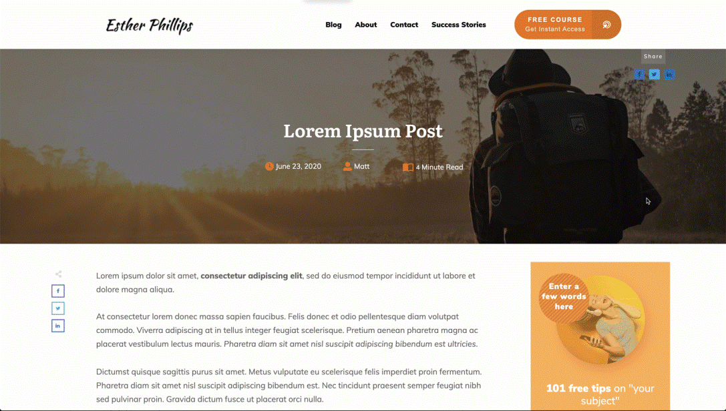

User Portal

- After the greeting ‘Good Afternoon’ at the top of the page, it should only display the user’s first name, not full name.
- The introductory text on top of the Draft tab needs amending to the information below:
“This is your private space to list all the tasks weighing your mind. Please note that your assistant cannot access the tasks listed here. When you're ready to delegate a task, provide further details for each task and click 'Create Task'. ”
- Pending tab: change the introductory text to:
“Your assistants will prioritise these pending tasks based on the deadlines you set. Sit back, relax, and enjoy seeing your to-do list shrink!”
- Completed tab: Redo the introductory to:
“Here, you'll find all previous tasks were completed or cancelled. Use this section to review your archived tasks.
- We need to ensure the assistants' full names aren’t revealed to the end user. So it should just be a first-name basis.
- Within a task page, the “Edit task” button disappears, when you click on the View min-task, attachment, and Task Events tabs.
- Rename the following tabs: ‘Message Handler’ to ‘Chat’. ‘Task Events’ to ‘Events’. ‘View mini-tasks’ to ‘Mini-tasks’.
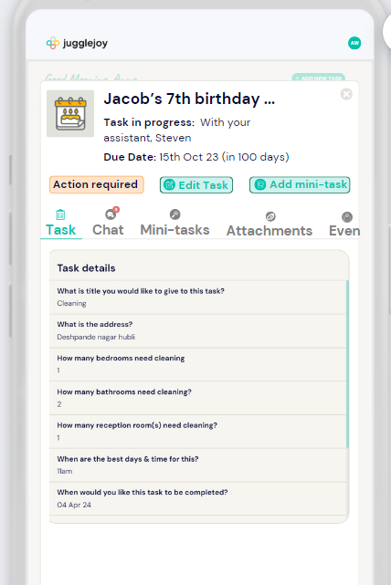

- Assistant and Handler logins shouldn’t appear on the main site, maybe you can provide me with the link, which we can share internally.

